**Web Portal 1.0**

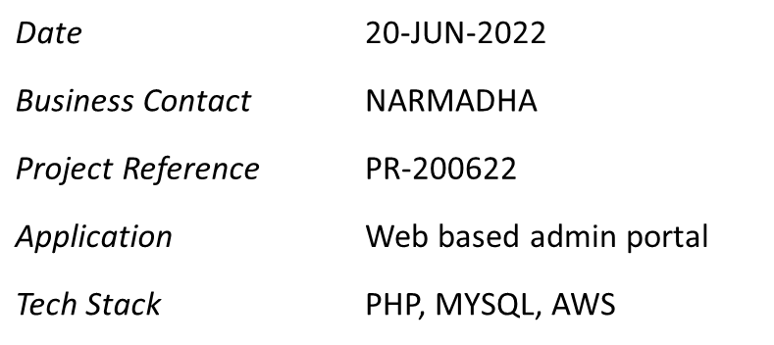

cODE REVIEW REPORT

**VERSION 1.0**

DOCUMENT HISTORY

| **DOCUMENT APPROVAL HISTORY** | |
| --- | --- |
| Prepared By | Narmadha H |
| Reviewed By | XYZ |
| Approved By | *AABBCC* |

| **DOCUMENT REVISION HISTORY** | | | |
| --- | --- | --- | --- |
| Date | Document Version | Revision Description | Author |
| 20/06/2022 | 1.0 | Initial Version | Narmadha H |
| 21/06/2022 | 1.1 | Updated Review comments | Narmadha H |
|  |  |  |  |
|  |  |  |  |
|  |  |  |  |
|  |  |  |  |
|  |  |  |  |
|  |  |  |  |
|  |  |  |  |
|  |  |  |  |

TABLE OF CONTENTS

1. INTRODUCTION 1

2. CODE REVIEW report template 1

APPENDIX A. CODE REVIEW CHECKLIST - MANUAL A-1

# INTRODUCTION

The Code Review Report summarizes the results of the Peer / Code review been performed on the Front end (PHP) and Backend(MYSQL) codes on real time basis.

VisualCodeGripper Tool has been used for Code Scanning / Review.

# CODE REVIEW report template

CODE REVIEW REPORT for Web Portal 1.0 Implementation

| **APPROVALS** | | |
| --- | --- | --- |
| NAME/TITLE | SIGNATURE | DATE |
| *Mr ABC*  *Developer* | *ABC* | *21-Jun-2022* |
| *Mr XYZ*  *Tech Lead* | *XYZ* | *22-Jun-2022* |
| *MR BBA*  *Technical Manager* | *BBA* | *23-Jun-2022* |

# 

1. CODE REVIEW CHECKLIST - MANUAL

**Attached below is the detailed Code Review checklist performed for Frontend (PHP) – Ex – NotificationController. PHP and IndustryController.PHP along with Seeders such as CountrySeeder.PHP**

